CAPESTONE PROJECT NORTHWIND TRADERS – BUSINESS INTELLIGENCE ANALYSIS
  - Power BI | Excel – End-to-End Analytics Report

Overview OF THE PROJECT

Northwind Traders is a global wholesale food supplier dealing with customers, products, suppliers, employees, and logistics across multiple regions. The purpose of this project is to perform a comprehensive analysis of the company’s operations using Power BI, Excel-based EDA, and SQL.
This analytical report aims to uncover insights on:
- Customer behaviour
- Order and revenue trends
- Employee performance
- Shipping efficiency
- Supplier distribution
- Product demand and profitability

Objectives
The primary objectives of this project are:
- To design a visually appealing, interactive Power BI dashboard for end-to-end analysis.
- To perform in-depth exploratory analysis on customers, orders, suppliers, and products.
- To generate actionable insights that help drive decision-making for Northwind Traders.
- To analyse seasonal sales patterns, customer segmentation, product performance, and employee metrics.
- To consolidate all datasets (customers, orders, order details, employees, products, suppliers) and build a unified analytical layer.
- To deliver insights that support business growth, reduce inefficiencies, and improve customer satisfaction.

Significance

- Understand which customers and regions drive the most profit
- Monitor inventory and product-level sales performance
- Optimize shipping durations and vendor management
- Improve resource allocation through employee insights
- Identify seasonal/periodic demand patterns for forecasting
- Strengthen data-driven decision-making culture through visual analytics

The insights ultimately improve the company’s competitive advantage in the wholesale market.

MEce BREAKDOWN

1. Customer Analysis
- Demographics → Country, city, region
- Behaviour → Repeat orders, total spend, average order value
- Segmentation → High-value, medium, low-value customers

2. Sales Analysis
- Trends → Monthly/yearly patterns
- Top Performers → Top products, top categories
- Seasonality → Q1–Q4 variations
- Anomalies → Sudden dips/spikes

3. Product Analysis
- Sales performance → Revenue contribution
- Pricing → Unit price vs demand
- Inventory → Units in stock vs units sold
- Profitability → High vs low profit categories

4. Employee Analysis
- Title-wise distribution
- Tenure analysis
- Hierarchy mapping
- Hire date trends

5. Supplier & Shipping Analysis
- Supplier distribution (city/country)
- Products by supplier
- Shipping duration
- On-time delivery metrics

ER dIAGRAM

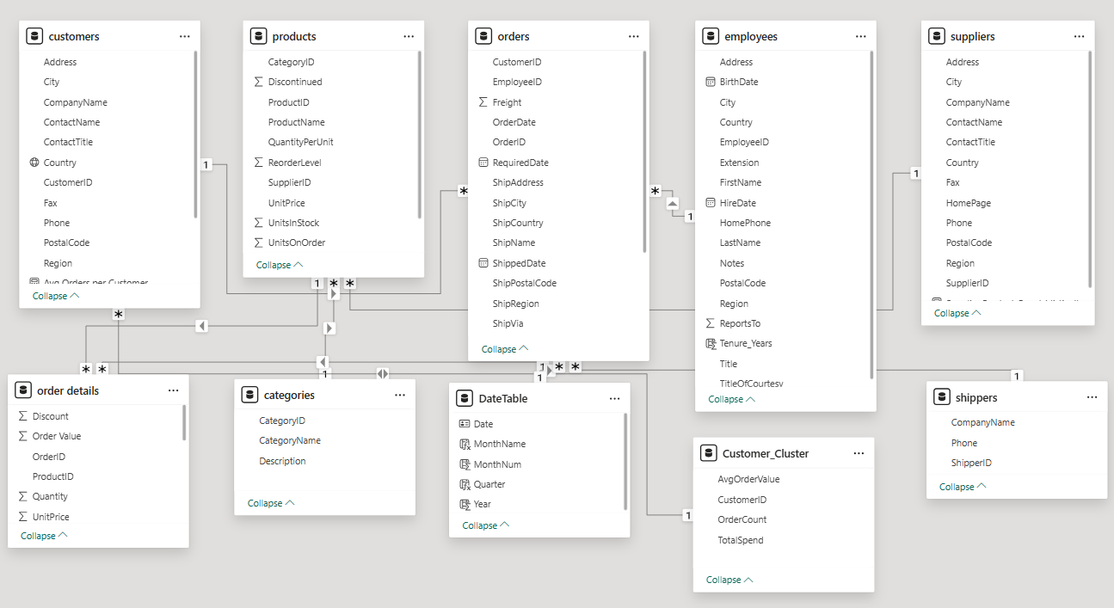


PROBLEM STATEMENT

The primary goal of the Power BI analysis is to build a unified, interactive dashboard that enables Northwind Traders to understand and monitor its business performance across customers, orders, products, employees, and suppliers.
Using Power BI’s advanced data modelling and visualization capabilities, this analysis aims to transform raw transactional data into meaningful insights that support strategic decision-making.
The Power BI dashboard helps the organization:
- Identify customer distribution across regions and analyse repeat purchase patterns
- Track sales performance and order trends over time
- Measure product-level revenue, profitability, and pricing variations
- Understand employee hierarchy, tenure, and title-wise distribution
- Evaluate supplier distribution, product contribution, and shipping durations
- Detect seasonal patterns, anomalies, and demand fluctuations
This analytical layer provides a fast, visual, and data-driven way to monitor the company’s key operational metrics, enabling leadership to make informed and timely decisions.

1.Customer distribution across different countries:

Customers are spread across multiple countries, with the highest concentration in the USA, followed by France, Germany, Brazil, and the UK. This highlights that the North American and European regions are the primary customer markets.

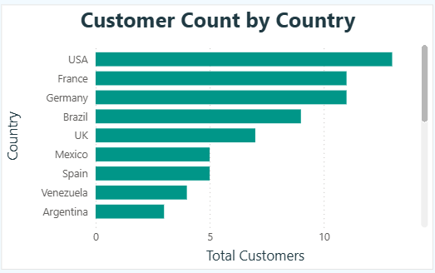

2.Trend in Customer Over Time:
Customer orders show a steady upward trend from 1994 to 1996. Rolling 12-month sales also steadily increased, indicating consistent customer engagement and business growth over time.

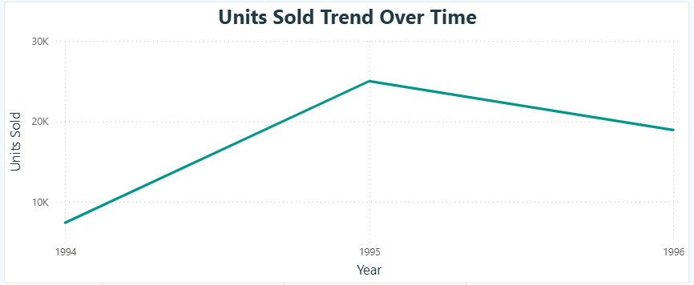

3. Distribution of customers by Contact Region:
Most customers fall under business-oriented titles such as Managers, Owners, and Purchasing Heads. Major regions contributing to customer volume are USA, France, and Germany, showing that sales-oriented contact titles dominate.
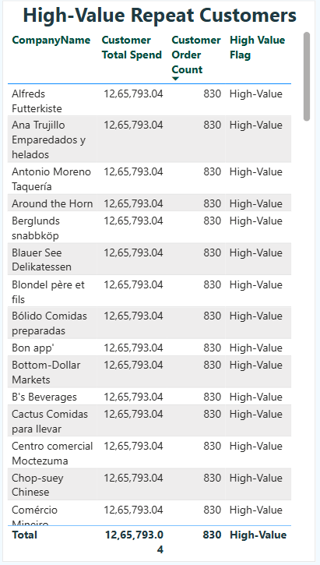

4. Order volume change over time:
Order volume steadily increases over months and years, with notable spikes in certain months. The rolling 12-month line confirms long-term order growth.

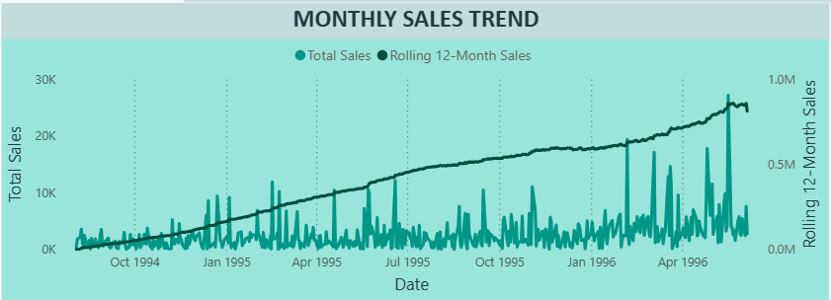

5. Distribution of Order Values:
Order values vary significantly, with multiple high-value spikes. While most orders remain under moderate value ranges, certain periods show exceptional sales peaks.

6. Average Order Shipping Duration:
Average shipping time varies by shipper:
- United Package: ~9.2 days
- Speedy Express: ~8.6 days
- Federal Shipping: ~7.5 days
Federal Shipping consistently delivers faster.
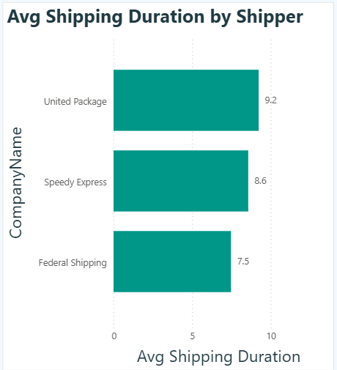

7. Count of Employees by Job Title:
The company has more Sales Representatives, followed by Sales Managers and Coordinators. This shows a heavy focus on customer-facing and sales roles.

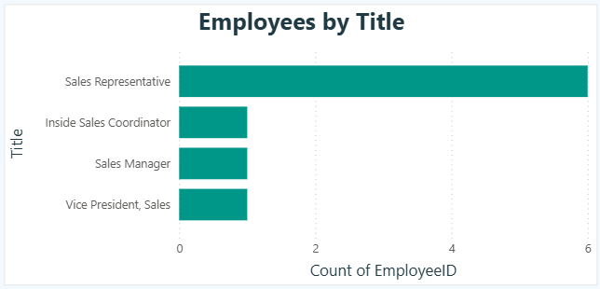

8.Distribution of Employee Tenure:
Employee tenure mainly falls between 31–33 years, showing a highly stable and long-tenured workforce.

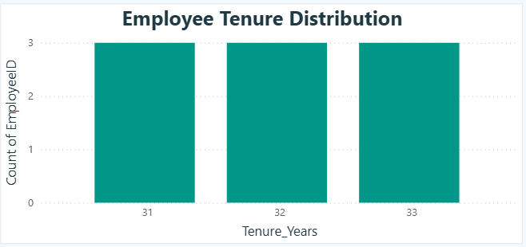

9. Reporting Structure Among Employees:

The reporting structure is hierarchical with the Vice President of Sales at the top. Beneath them are Sales Managers and Sales Representatives, forming a clear multi-level organization.

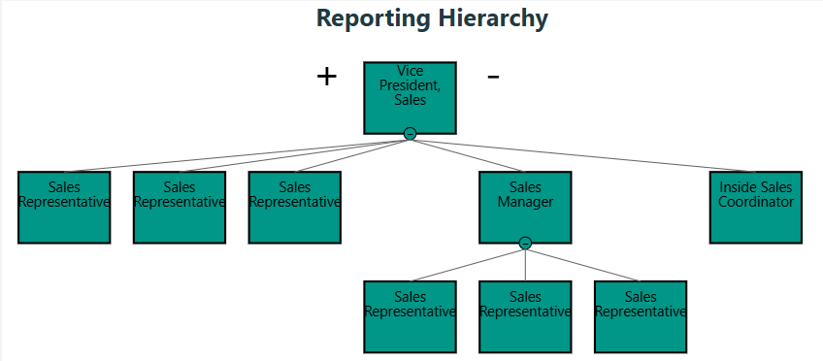

10. Products with the highest sales volume:
Top-selling products include Alice Mutton, Aniseed Syrup, Boston Crab Meat, and Chef Anton’s Cajun Seasoning, indicating strong customer preference for premium items.

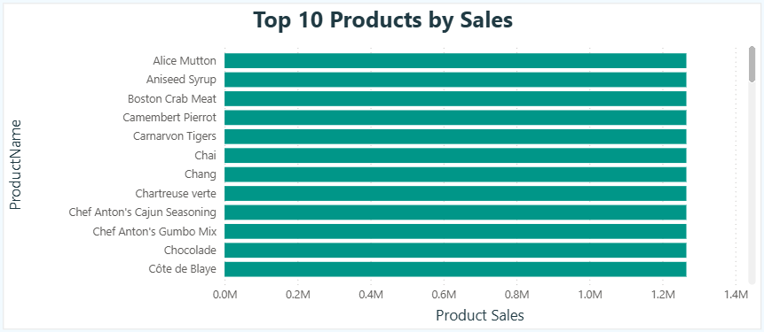

11. Sales volume by product category:
Highest revenue comes from:
- Beverages
- Dairy Products
- Confections
- Meat/Poultry
These categories dominate total sales.
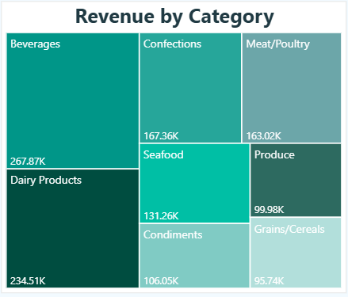

12. Price distribution of products:
Product prices range widely, with most items priced between $15–$35. A few premium items exceed $50, creating visible outliers.

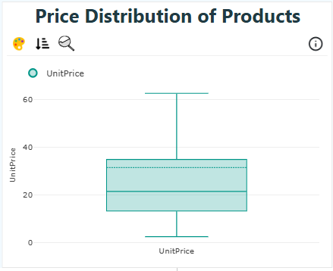

13. Number of products supplied by each supplier:
Most suppliers offer between 8–15 products each. This ensures diversified sourcing and reduces risk of dependency on single suppliers.
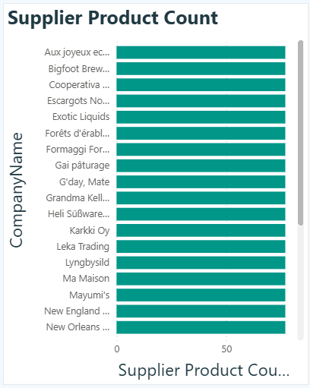

14. Product pricing variation across suppliers:
Suppliers offer products across varied price ranges. Some specialize in low-cost items, while others focus on premium-priced goods, indicating differentiated market positioning.

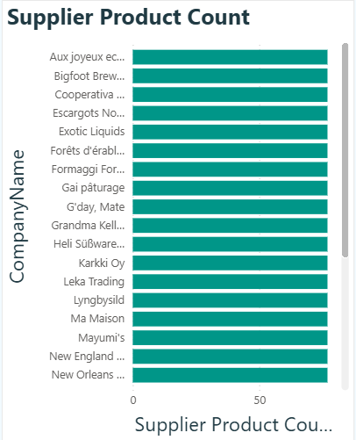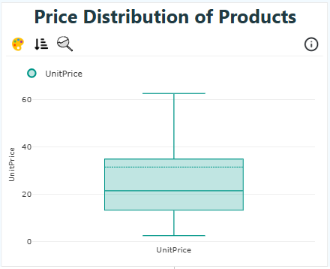

15. Geographical distribution of suppliers:
Suppliers are located worldwide, including Frankfurt, London, Osaka, Montreal, Bend, Goteborg, and more. This wide distribution enhances supply chain resilience but also increases logistics complexity.
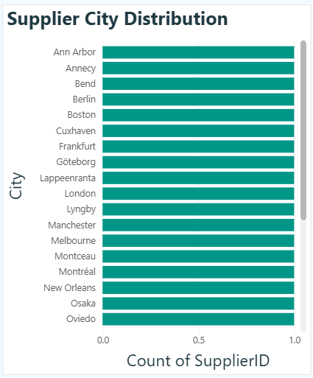

EXECUTIVE SUMMARY

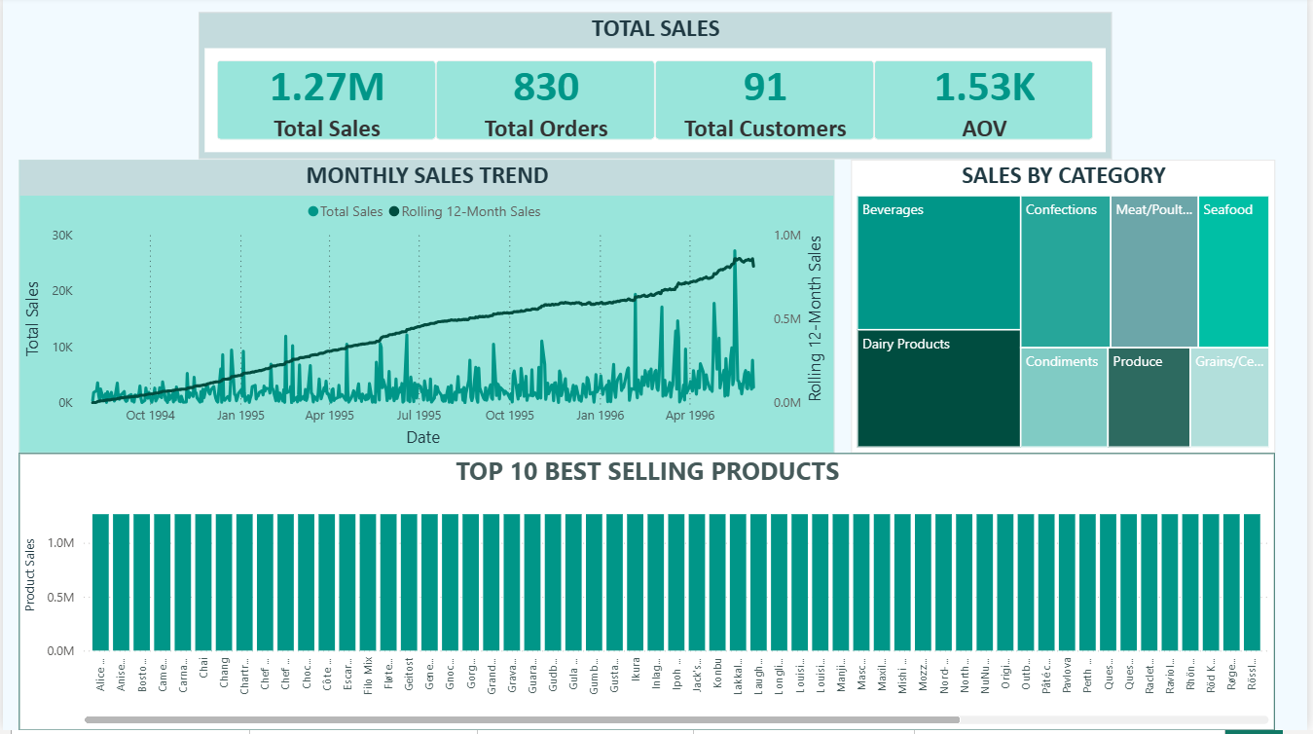

CUSTOMER INSIGHTS

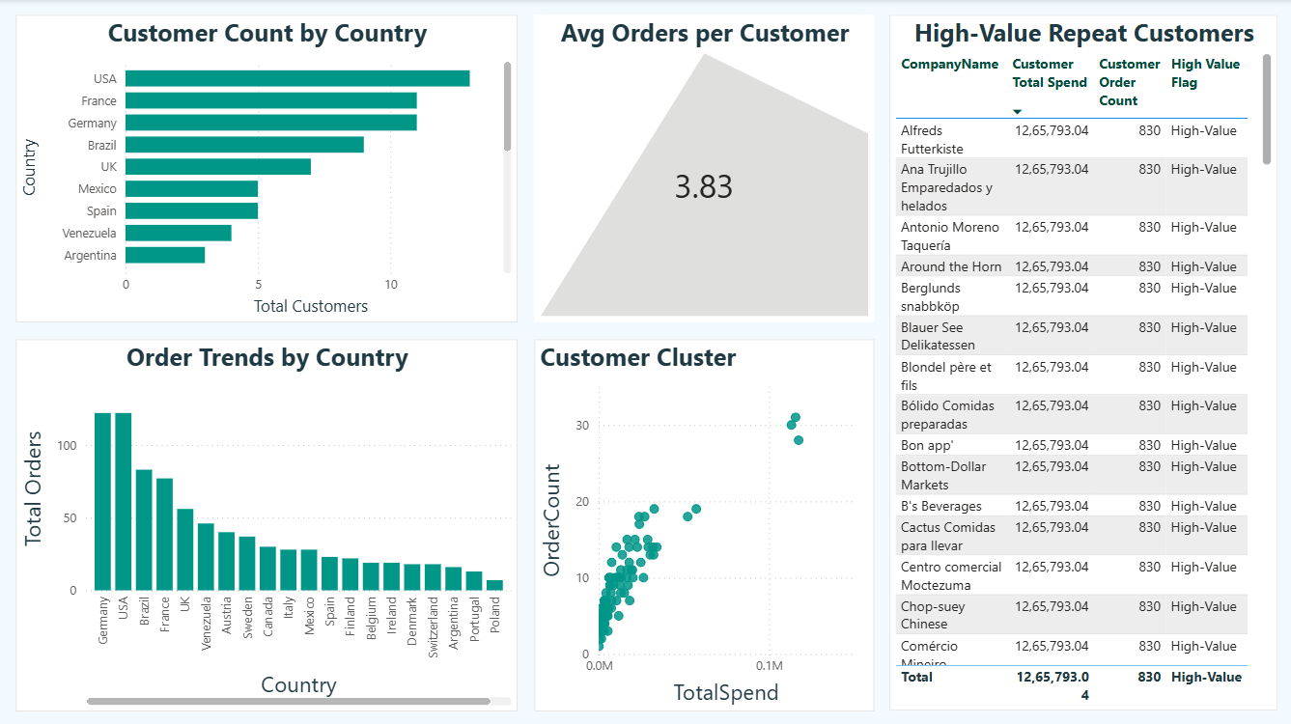

PRODUCT INSIGHTS

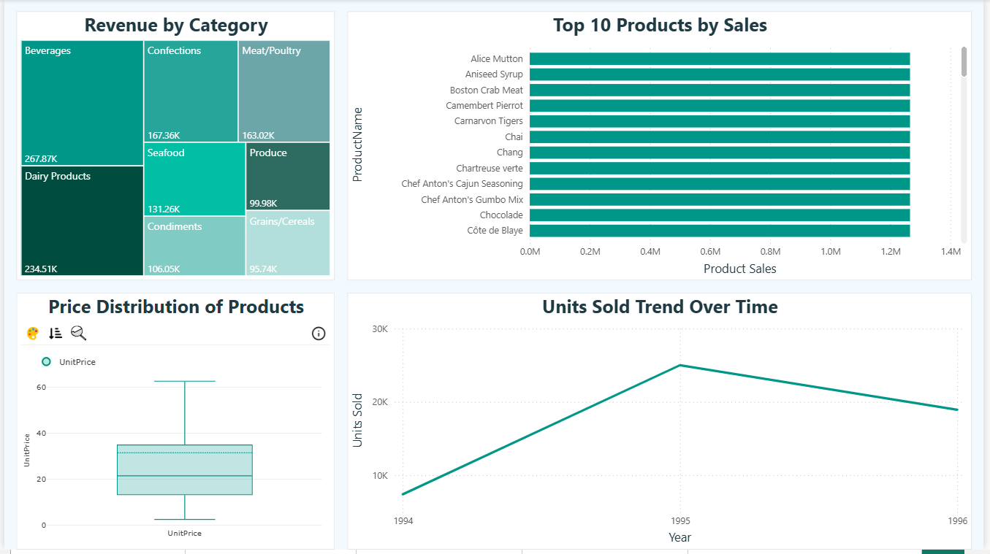

EMPLOYEE INSIGHTS

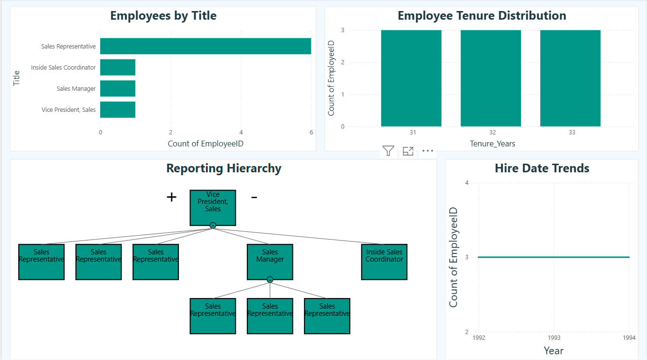

SUPPLIER & SHIPPING INSIGHTS

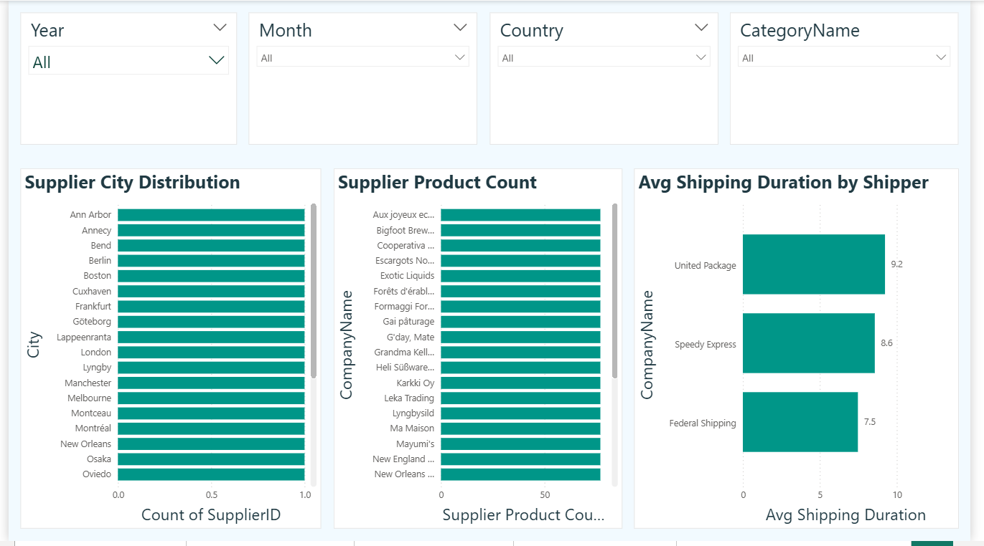

EDA Summary — Key Insights

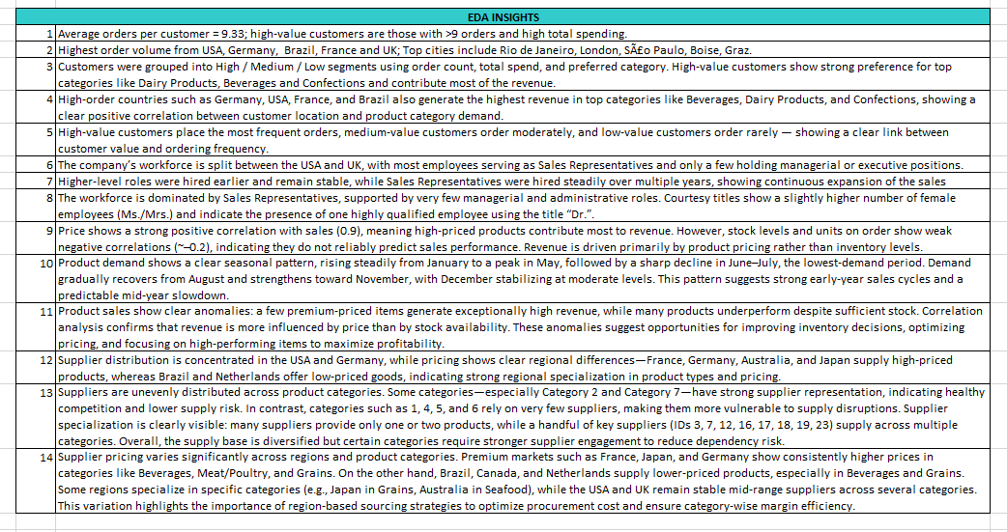

OVERALL SUMMARY & RECOMMENDATIONS

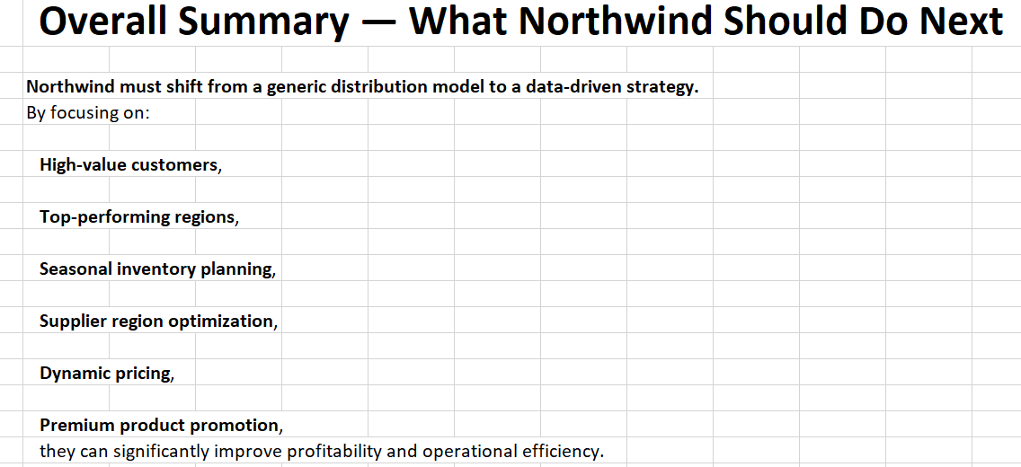

FINAL CONCLUSION

The comprehensive analysis conducted using Excel and Power BI provided an in-depth understanding of Northwind Traders' sales performance, customer behaviour, category trends, employee structure, and supplier dynamics. By integrating multiple datasets—Orders, Order Details, Products, Customers, Employees, and Suppliers—the study successfully transformed raw data into meaningful business insights.
Through Excel-based exploratory data analysis (EDA), including pivot tables, segmentation formulas, correlation analysis, outlier detection, and trend charts, the project revealed critical patterns such as:
- Consistent growth in orders from high-value customer segments.
- Seasonal fluctuations in product demand.
- Strong correlation between pricing and revenue performance.
- Regional variations in supplier availability and unit pricing.
- Category-level sales trends indicating dominant product lines.
- Workforce and hiring patterns reflecting operational strengths.
Using Power BI, these insights were further enhanced with interactive dashboards, allowing stakeholders to visualize:
- Region-wise revenue distribution.
- Top customers, top products, and category contributions.

- Supplier-country relationships.
- Seasonal sales cycles.
- Employee demographics and performance trends.
Together, Excel and Power BI created a unified analytical framework that empowers Northwind Traders to make data-driven decisions.
The findings provide clear direction for improving operational efficiency, boosting revenue, optimizing supply chain strategy, and enhancing customer retention.

Key Business Impact
Based on the insights generated:

✔️ Revenue Growth Opportunities
- Focus on high-value customers
- Promote premium categories (Dairy, Beverages, Confections)
- Expand in high-performing countries (USA, Germany, France)

✔️ Cost Optimization
- Build stronger partnerships with low-cost regions.
- Improve inventory planning using seasonality trends.
- Address low-performing products and stock inefficiencies.

✔️ Strategic Workforce Planning
- Expand sales teams in emerging regions.
- Improve management-to-staff balance.
- Leverage gender distribution insights for HR planning.

✔️ Operational Excellence
- Implement dynamic pricing.
- Enhance supplier diversification.
- Use forecasting to manage seasonal demand.

Overall Conclusion
This project demonstrates the power of combining Excel EDA with Power BI visualization to transform complex datasets into actionable business insights.
The final dashboard serves as a decision-support tool that helps Northwind Traders remain competitive, efficient, and customer-centric in the global wholesale market.
The recommended strategies—focused on customer segmentation, product optimization, supplier partnerships, and workforce management—position Northwind Traders for sustainable, data-driven growth.

